**FACULDADES INTEGRADAS DE ARARAQUARA**

**BACHARELADO EM SISTEMAS DE INFORMAÇÃO**

**LUIS FILIPE CAMBIAGHE GUEDES**

**GUILHERME DIEGO ALBINO FRANCISCO**

**PROJETO DE BANCO DE DADOS.**

**ARARAQUARA – SP.**

**2018**

Sumário

1. Mer: 3

2. Modelo relacional: 3

3. Criação das tabelas ou “create table”: 3

4. Consultas ou “Queries”: 5

# Mer:

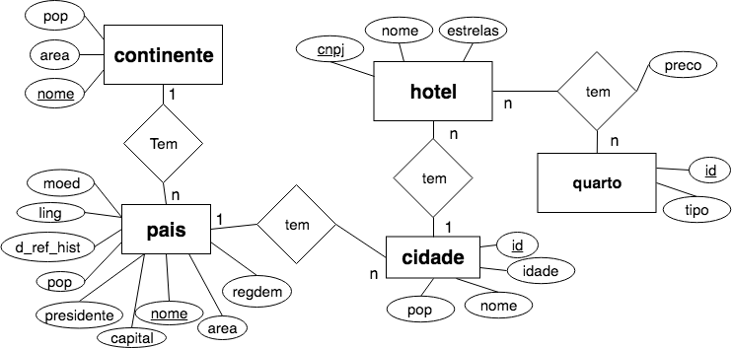

# Modelo relacional:

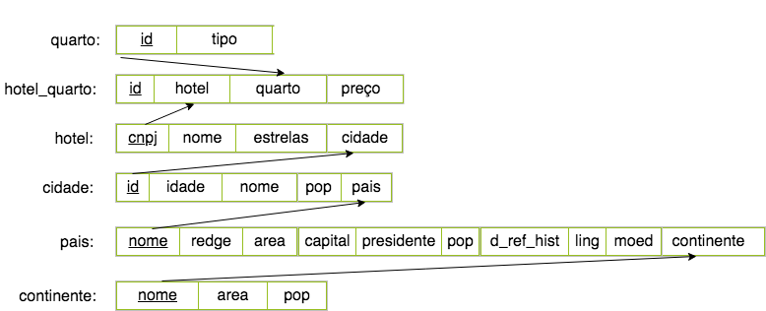

# Criação das tabelas ou “create table”:

|  |  |  |  |  |  |  |  |  |  |  |  |  |  |  |  |  |  |  |  |  |  |  |  |  |  |  |  |  |  |  |  |  |  |  |  |  |  |  |  |  |  |  |  |  |  |  |  |  |  |  |  |  |  |  |  |  |  |  |  |  |  |  |  |  |  |  |  |  |  |  |  |  |  |  |  |  |  |  |  |  |  |  |  |  |  |  |  |  |  |  |  |
| --- | --- | --- | --- | --- | --- | --- | --- | --- | --- | --- | --- | --- | --- | --- | --- | --- | --- | --- | --- | --- | --- | --- | --- | --- | --- | --- | --- | --- | --- | --- | --- | --- | --- | --- | --- | --- | --- | --- | --- | --- | --- | --- | --- | --- | --- | --- | --- | --- | --- | --- | --- | --- | --- | --- | --- | --- | --- | --- | --- | --- | --- | --- | --- | --- | --- | --- | --- | --- | --- | --- | --- | --- | --- | --- | --- | --- | --- | --- | --- | --- | --- | --- | --- | --- | --- | --- | --- | --- | --- | --- | --- |
| |  | | --- | | create table continente ( | |  | nome varchar (60) NOT NULL PRIMARY KEY, | |  | area bigint NOT NULL, | |  | pop bigint NOT NULL, | |  | ); | |  |  | |  | create table pais ( | |  | nome varchar (60) NOT NULL PRIMARY KEY, | |  | area bigint NOT NULL, | |  | pop bigint NOT NULL, | |  | moed varchar (110) NOT NULL, | |  | ling varchar (110) NOT NULL, | |  | d_ref_hist date NOT NULL, | |  | presidente varchar (110) NOT NULL, | |  | capital varchar (110) NOT NULL, | |  | regdem varchar (110) NOT NULL, | |  | continente_id varchar (60) NOT NULL REFERENCES continente(nome) | |  | ); | |  |  | |  | create table cidade ( | |  | id integer IDENTITY(1,1) NOT NULL PRIMARY KEY, | |  | idade date NOT NULL, | |  | nome varchar (110) NOT NULL, | |  | pop integer NOT NULL, | |  | descricao text, | |  | pais_id varchar (60) NOT NULL REFERENCES pais(nome), | |  | ); | |  |  | |  | create table hotel ( | |  | cnpj integer NOT NULL PRIMARY KEY, | |  | nome varchar (110) NOT NULL, | |  | estrelas integer NOT NULL, | |  | cidade_id integer NOT NULL REFERENCES cidade(id) | |  | ); | |  |  | |  | create table quarto ( | |  | id integer IDENTITY(1,1) NOT NULL PRIMARY KEY, | |  | tipo varchar (110) NOT NULL, | |  | ); | |  |  | |  | create table hotel_quarto ( | |  | id integer IDENTITY(1,1) NOT NULL PRIMARY KEY, | |  | preco decimal NOT NULL, | |  | hotel_id integer NOT NULL REFERENCES hotel(cnpj), | |  | quarto_id integer NOT NULL REFERENCES quarto(id) | |  | ) | |

# Consultas ou “Queries”:

|  |  |  |  |  |  |  |  |  |  |  |  |  |  |  |  |  |  |  |  |  |  |  |  |  |  |  |  |  |  |  |  |  |  |  |  |  |  |  |  |  |  |  |  |  |  |  |  |  |  |  |  |  |  |  |  |  |  |  |  |  |  |  |  |  |  |  |  |  |  |  |  |  |  |  |  |  |  |  |  |  |  |  |  |  |  |  |  |
| --- | --- | --- | --- | --- | --- | --- | --- | --- | --- | --- | --- | --- | --- | --- | --- | --- | --- | --- | --- | --- | --- | --- | --- | --- | --- | --- | --- | --- | --- | --- | --- | --- | --- | --- | --- | --- | --- | --- | --- | --- | --- | --- | --- | --- | --- | --- | --- | --- | --- | --- | --- | --- | --- | --- | --- | --- | --- | --- | --- | --- | --- | --- | --- | --- | --- | --- | --- | --- | --- | --- | --- | --- | --- | --- | --- | --- | --- | --- | --- | --- | --- | --- | --- | --- | --- | --- | --- |
| |  | | --- | | -- Quais os paises cadastrados no BD? | |  | SELECT * FROM pais | |  |  | |  | -- Nomes dos continentes | |  | SELECT nome FROM continente | |  |  | |  | -- Continentes dos Paises Cadastrados no DB | |  | SELECT continente_id FROM pais | |  | GROUP BY continente_id | |  |  | |  | -- Qual é a Capital da Finlândia? | |  | SELECT capital FROM pais p | |  | WHERE p.nome = "Finlândia" | |  |  | |  | -- Paises Asiaticos que obterem a independecia depois de 1950? | |  | SELECT d_ref_hist, nome FROM pais p | |  | WHERE p.continente_id = "Asia" | |  | AND p.d_ref_hist > '1950' | |  | ORDER BY p.d_ref_hist | |  |  | |  | -- Paises falando a lingua portuguesa na africa? | |  | SELECT * FROM pais p | |  | WHERE p.ling = "Português" | |  | ORDER BY p.nome | |  |  | |  | -- Quais as cidades Brasileiras? | |  | SELECT * FROM cidade c | |  | WHERE c.pais_id = "Brasil" | |  | ORDER BY c.nome | |  |  | |  | -- Qual é a população mundial? | |  | SELECT SUM(pop) as populacao_mundial | |  | FROM continente | |  |  | |  | -- Número das cidades chamadas "São Luís" no mundo? | |  | SELECT COUNT(*) as cidades_sao_luis FROM cidade c | |  | WHERE c.nome LIKE "%São Luís%" | |  |  | |  | -- Em qual pais se encontra o hotel mais barato? | |  | SELECT TOP 1 p.nome as nome_do_pais_com_hotel_mais_barato FROM hotel_quarto hq | |  | INNER JOIN hotel h ON hq.hotel_id = h.cnpj | |  | INNER JOIN cidade c ON h.cidade_id = c.id | |  | INNER JOIN pais p ON c.pais_id = p.nome | |  | ORDER BY preco | |